The Hunter from BBC Studios launches exclusively on Wondery+
New true crime series is available starting July 8, 2025
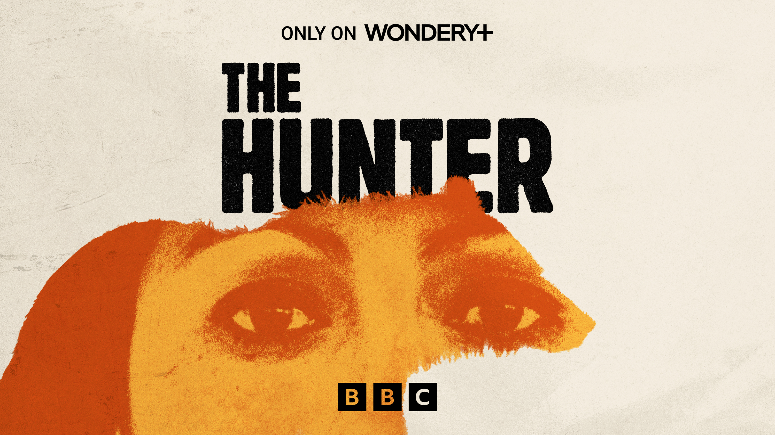

+

BBC Studios Audio, the award-winning producers of To Catch A Scorpion and Stalked, will release a powerful new series, The Hunter, exclusively on Wondery+.

The Hunter is an astonishing tale of justice, survival, and a mother’s unbreakable will. Narrated by the actor, theatre director, and advocate Anaya Echo Hawk, the six-part series follows Lydia Lerma, an American mother who risks everything to find justice for her son.

After her son’s abuser escapes justice and flees to Mexico, Lydia assembles an unlikely crew - a police detective, a professional hunter, a district attorney, a Navajo hand trembler, an anonymous tipster, and an Apache medicine man - and takes matters into her own hands.

What follows is a relentless pursuit from Colorado’s Rocky Mountains to the streets of Cuauhtémoc, Mexico, and a dramatic courtroom showdown. The Hunter explores the strength of community, the healing power of nature, and the undeniable force of a mother’s love.

James Cook, Factual Creative Director for BBC Studios Audio, said:

“We are thrilled to bring this extraordinary story to international audiences on Wondery+. The Hunter is full of tension and jaw-dropping moments and has an extraordinary woman at its center – a mother determined to never give up on getting justice for her son. The series is another example of BBC Studios’ world-class narrative storytelling, and we can’t wait for audiences to be drawn into this gripping show”.

The Hunter is a BBC Studios Audio production. Emma Weatherill is the writer and producer, and Joe Kent is the executive producer. All episodes of the series launch on July 8th on Wondery’s premium subscription service, Wondery+.

